786
Name: Muhammad Sherjeel Akhtar
Roll No: 20p-0101
Subject: Computer Networks Lab
Task No: 4
Submitted To Respect Ma’am: Miss Hurmat Hidayat
Section: B

Task 1: DNS Server Configuration In Packet Tracer
Answer:
Step 1: First of all we will create a Topology.
Step 2: Place a server.
Step 3: Place a Switch
Step 4: Connect the Switch with the Server using a Copper-Cross-Over Cable.
Step 5: Place two Computers.
Step 6: Connect these two Computers with the Switch using a Straight-Through-Cables.
Step 7: Now first of all open the DNS-Server and go to its IP Configuration.
Step 8: Assign the following to the DNS-Server.
- Static IP Address (192.168.1.2)
- Subnet Mask
- Default Gateway
- DNS Server
Step 9: Now open the two PC’s one by one and assign the following to them.
- Static IP Address (192.168.1.3)(192.168.1.4)
- Subnet Mask
- Default Gateway
- DNS Server
Step 10: Now Configure DNS-Service on the generic Server.
Step 11: Open the DNS-Server.
Step 12: Go to the Services Tab.
Step 13: Then go to the DNS Tab.
Step 14: At there, do the specific DNS entries for both of the PC’s and the DNS-Server itself.
Step 15: Now perform a Ping Test from one PC to the other using the Domain Name.

Visual Demonstration:
Topology:
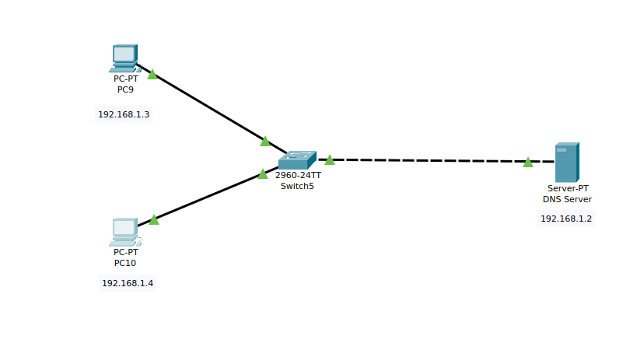
.

IP Configuration Of The Server:
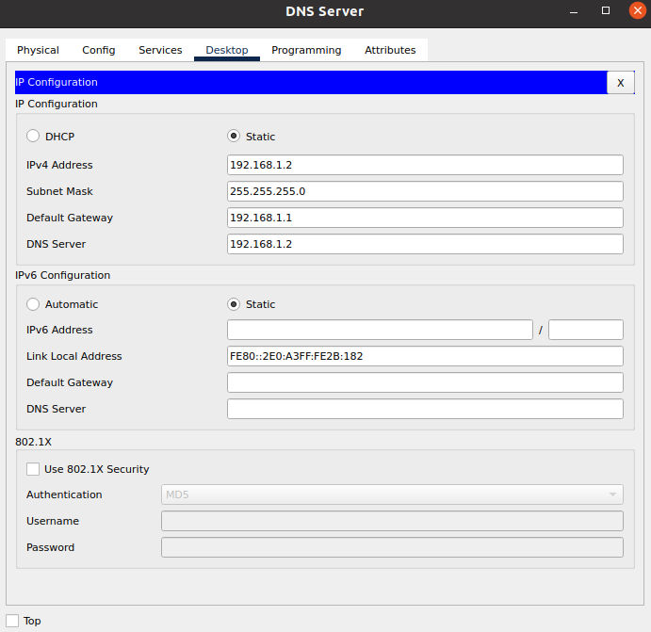
.

IP Configuration For PC-9:
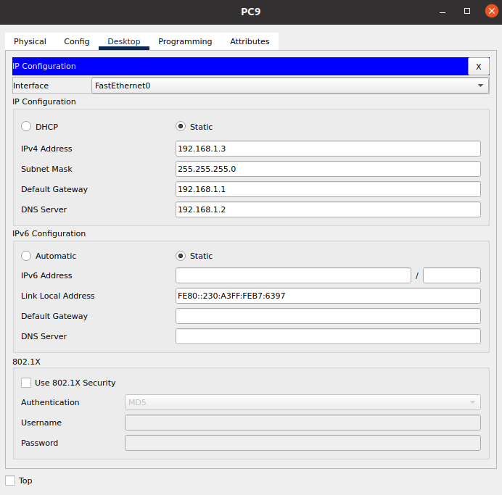
.

IP Configuration For PC-10:
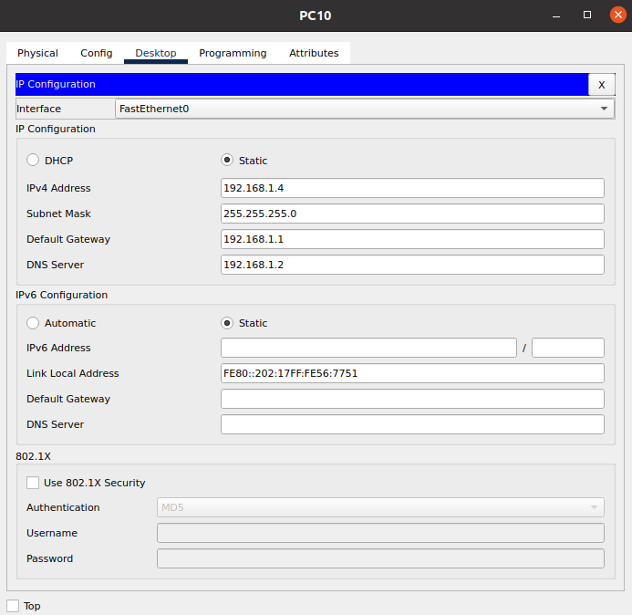

DNS Setting And DNS Entries In The DNS Server:
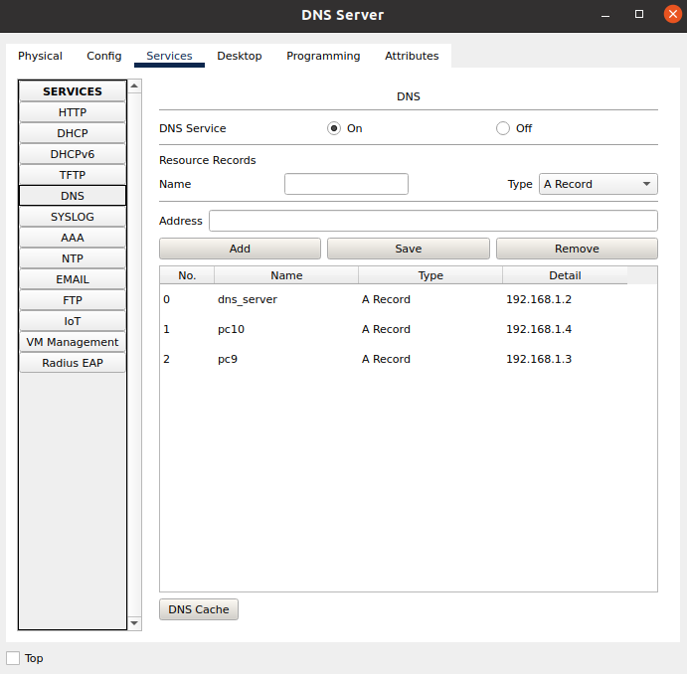

Ping Test From PC-10 To PC-9 Using The Domain Name:
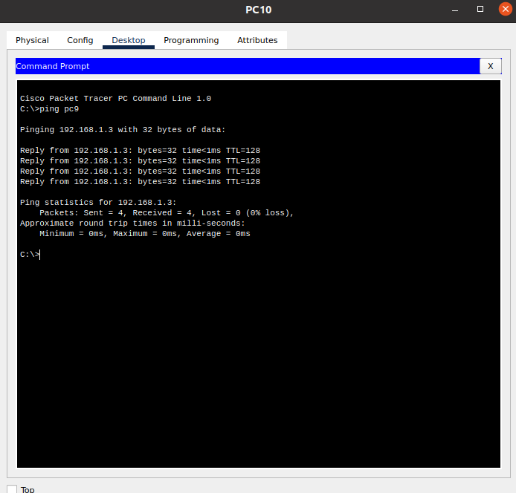

Task 2: Configuring DHCP Server On A Router
Answer:
Step 1: First of all we will build a topology.
Step 2: Place 3 Computer Devices and connect them with a switch.
Step 3: Place a router 2621XM and connect this router with switch.
Step 4: Now our topology for this task is completed.
Step 5: In this task, we will configure a DHCP server on a Router.
Step 6: On the router, we will configure interface fa0/0 to act as the default gateway.
Step 7: We will configure the router as a DHCP server using Command Line Interface.
Step 8: Open the CLI in the router by simply clicking on the router and going into the CLI Tab.
Step 9: Now write the following chain of commands on the router.
Chain Of Commands:
Command 1: Router>enable
Command 2: Router#configure terminal
Command 3: Router(config)#interface FastEthernet0/0
Command 4: Router(config-if)#ip address 192.168.1.1 255.255.255.0
Command 5: Router(config-if)#no shutdown
Command 6: Router(config-if)#ex
Command 7: Router(config)#ip dhcp pool P1
Command 8: Router(dhcp-config)#network 192.168.1.1 255.255.255.0
Command 9: Router(dhcp-config)#default-router 192.168.1.1
Command 10: Router(dhcp-config)#dns-server 192.168.1.10
Command 11: Router(dhcp-config)#ex
Command 12: Router(config)#ip dhcp excluded-address 192.168.1.1 192.168.1.10
Command 13: Now go to every Computer separately and open IP Configuration.
Command 14: For every PC. Click for DHCP Option in the IP Configuration menu.

Visual Demonstration:
Topology:
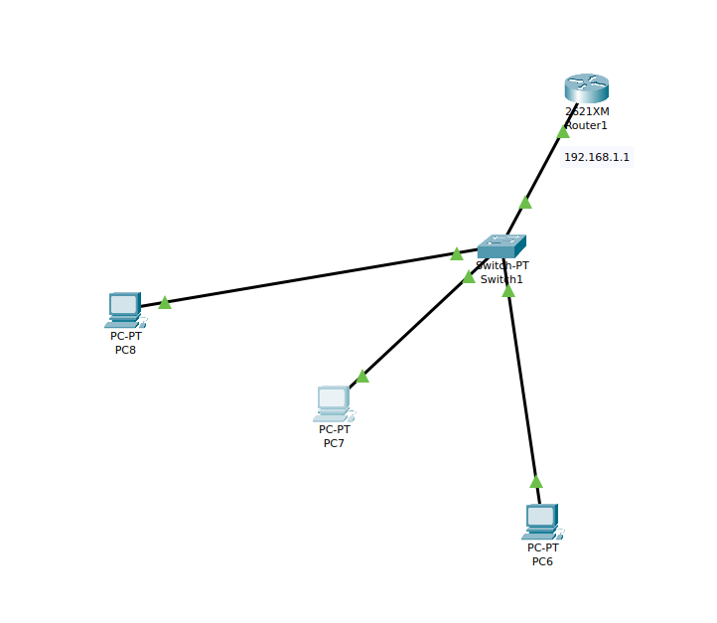
.

Router Configuration:

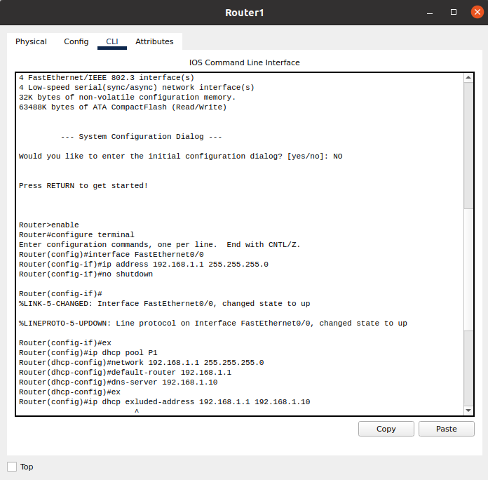

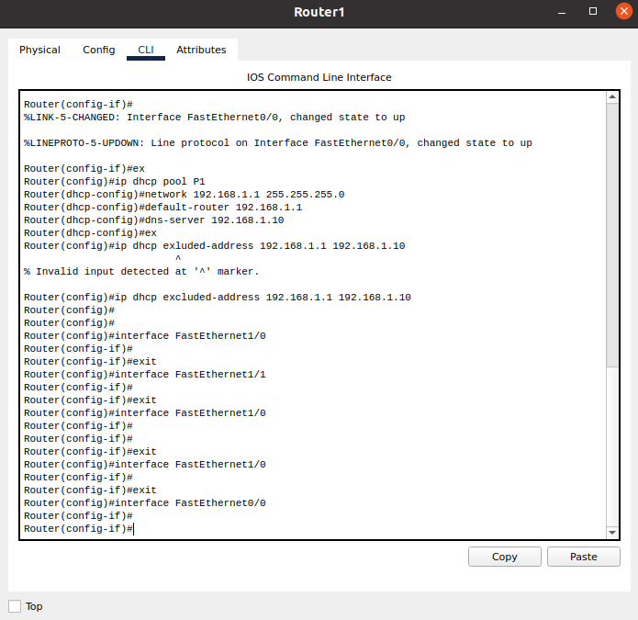
.

DHCP In IP Configuration On PC’s:
PC-8:
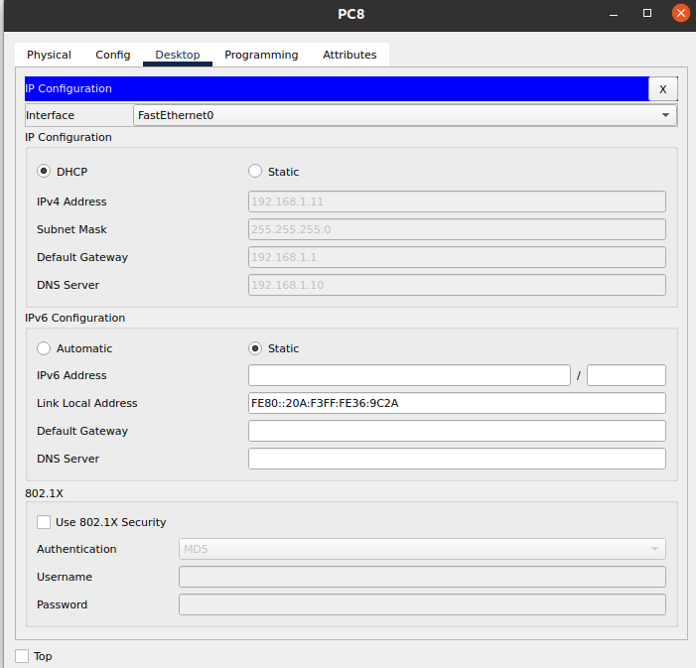
.

PC-7:
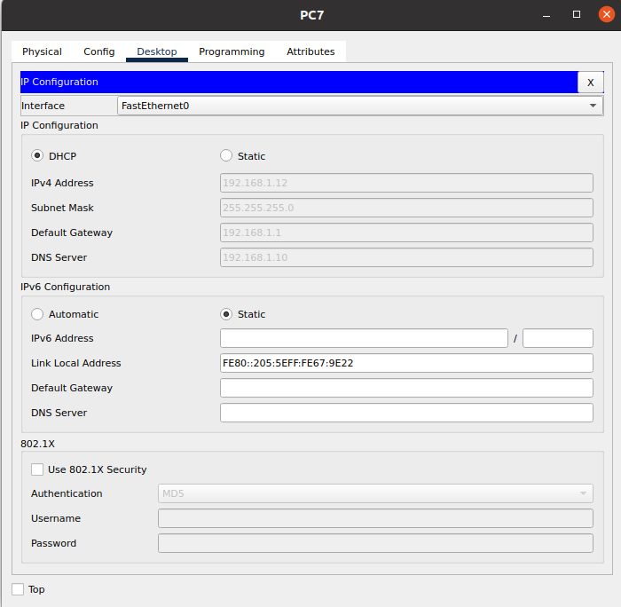
.

PC-6:
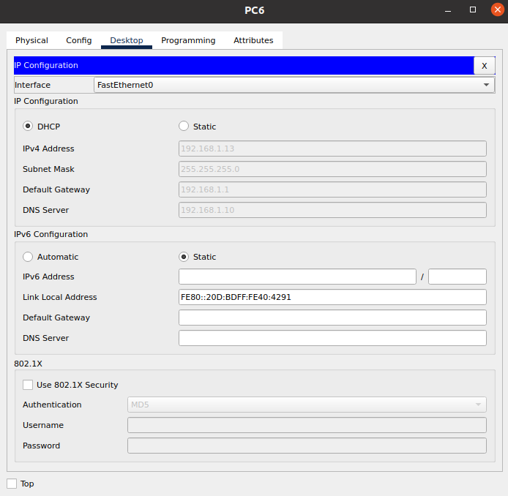
.

Ping Test From PC-7 To PC-8:
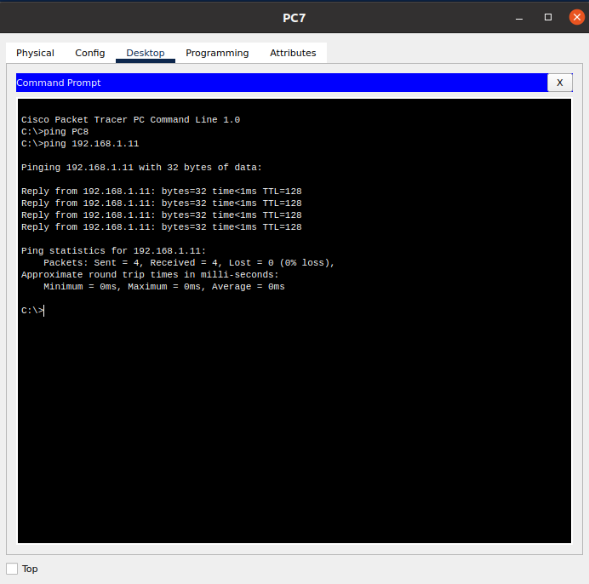
.

Task 3: Configuring DHCP service on a generic server
Answer:
Step 1: First of all we will build a topology.
Step 2: Place 3 Computer Devices and connect them with a switch.
Step 3: Place a server “Server-PT” and connect this server with switch.
Step 4: Now our topology for this task is completed.
Step 5: In this task, we will configure a DHCP service on a generic server.
Step 6: First of all we will configure a static IP address on the server.
Step 7: Then we will configure a DHCP service on the generic server.
Step 8: For this purpose, click on the server. Then click on the Services Tab. We will pick DHCP on the menu.
Step 9: We will set the DHCP Perimeters according to our need.
Setting Perimeters:
Pool name: serverPool
Default Gateway: 192.168.1.1
DNS Server: 192.168.1.10
Start IP Address: 192.168.1.0
Subnet Mask: 255.255.255.0
Maximum Number of users: 255

Visual Demonstration:
Topology:
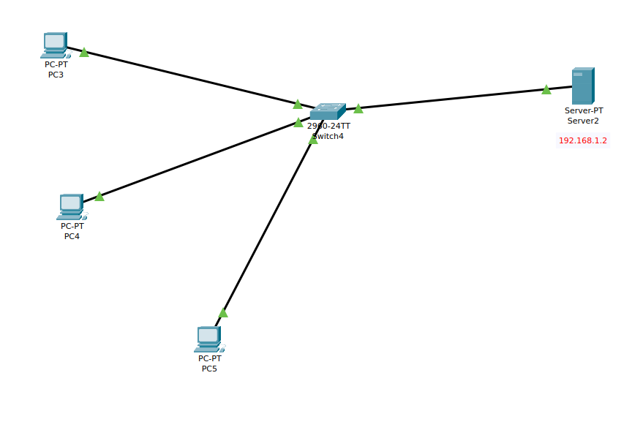
.

Setting Static IP For The Router:
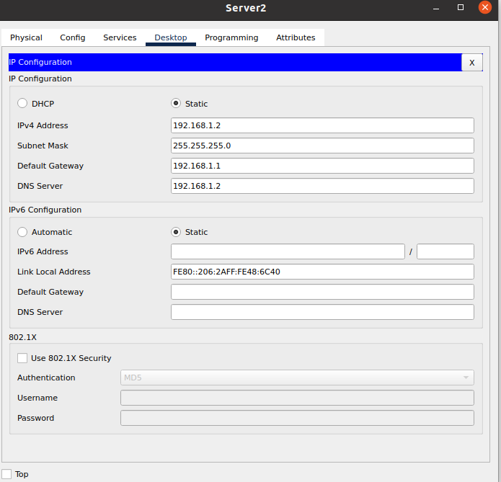
.

Configuring DHCP Services For The Router:
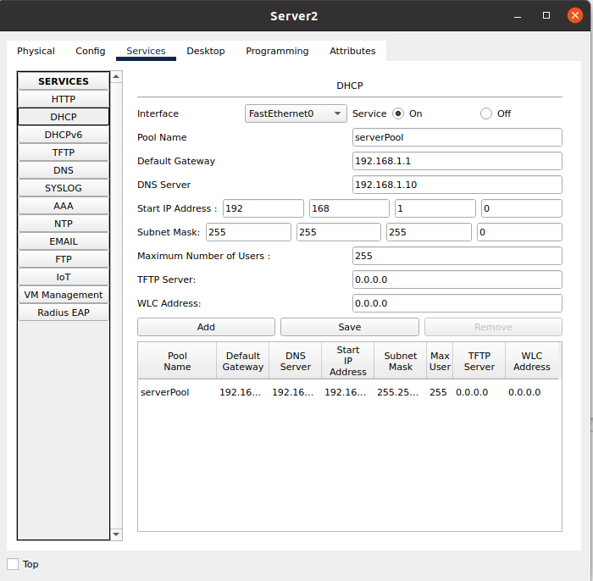
.

Assigning IP To The DHCP:
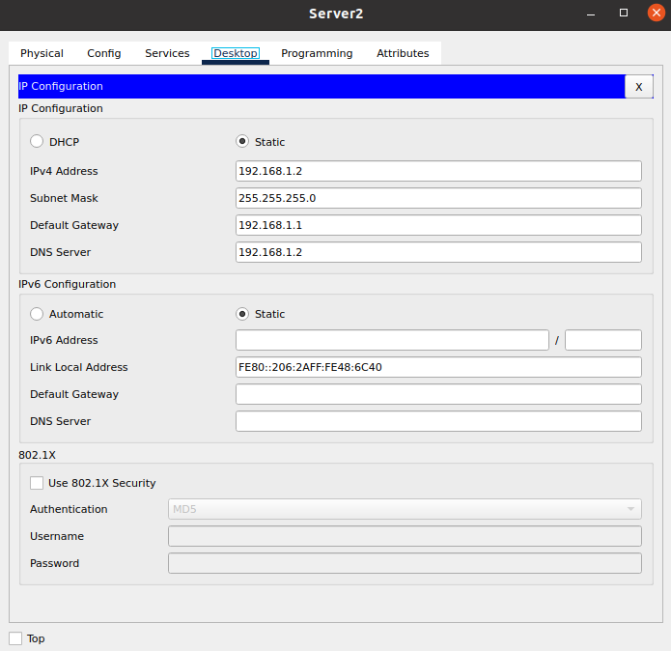
.

Enabling DHCP On Every Single PC:
PC-3:
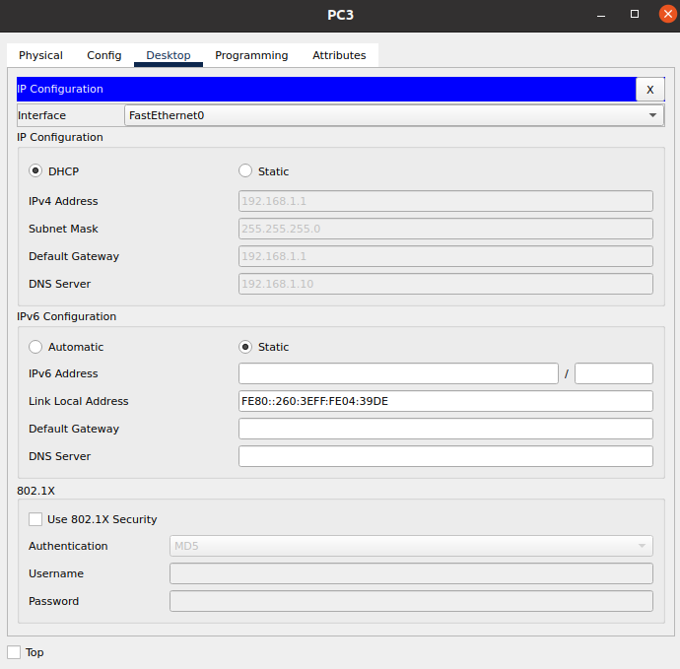
.

PC-4:
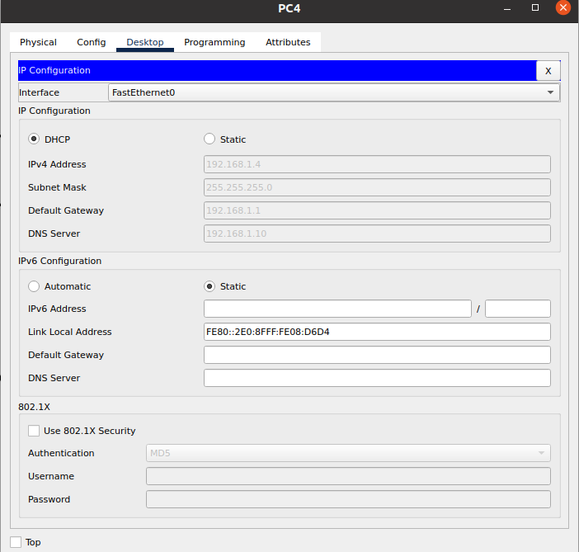
.

PC-5:
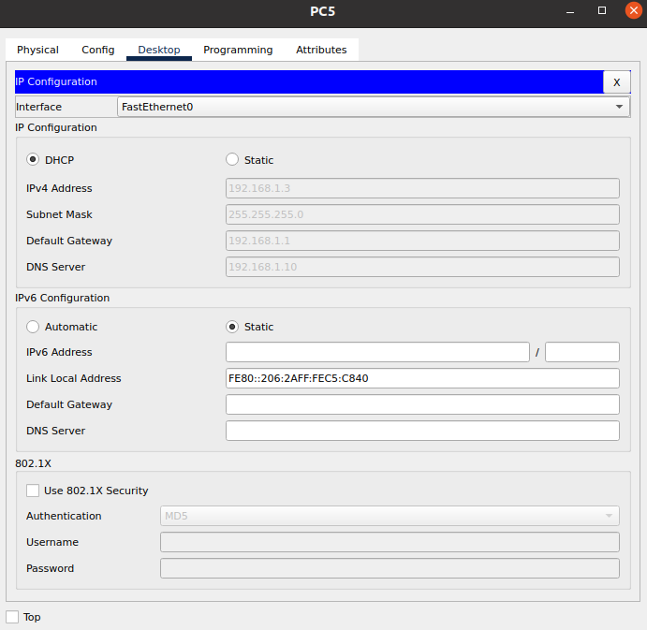
.

Pinging From PC-5 To PC-4:

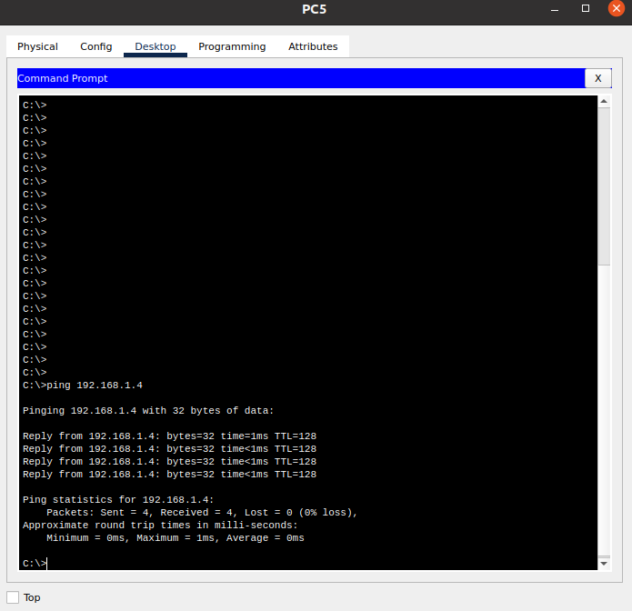
.

Task 4: Configuring DHCP, DNS and Web Server Configuration In Cisco Packet Tracer
Answer:
Step 1: Creating the Topology
Step 2: Place 3 servers,
- DHCP
- DNS
- Web-Server
Step 3: Place a Switch
Step 4: Connect all three servers with this switch
Step 5: Connect 2 PC’s with this server too.
Step 6: Now Place a router.
Step 7: Connect this Switch with the router.
Step 8: Now place another Switch
Step 9: Connect this newly placed Switch with the router.
Step 10: Place two PC’s and connect them with the newly placed Switch.
Key Point: The connect b/w all of these devices should be made with the COPPER-STRAIGHT-THROUGH cable.
Step 11: Open the router and configure the interface F0/0 to act as a default gateway for our LAN.
Step 12: Assign the IP Addresses to the F0/0 and F0/1 of the router.
Step 13: Apply the commands in the configuration mode on the Router.
Chain Of Commands:
ip dhcp pool P1
network 192.168.1.0 255.255.255.0
default-router 192.168.1.2
ip dhcp pool P2
network 192.168.2.0 255.255.255.0
default-router 192.168.2.2
Step 14: Now open the DHCP server and go to its IP Configuration tab.
Step 15: Assign the following in the IP Configuration Tab.
- IP Address
- Subnet Mask
- Default Gateway
- DNS Server
Step 16: Now go to the Services tab.
Step 17: Then go to the DHCP tab in the services tab.
Step 18: In the DHCP Settings add Pool P1 and Pool P2 with their respective IP Addresses.
Step 19: Then open the DNS server and go to its IP Configuration tab.
Step 20: Assign the following in the IP Configuration Tab.
- IP Address
- Subnet Mask
- Default Gateway
- DNS Server
Step 21: Go to the Services tab of DNS-Server.
Step 22: Then to go the DNS-Tab in the Services.
Step 23: Turn on the DNS-Services in the DNS-Tab.
Step 24: At there, add two IP Addresses with the following names.
www.dhcp.com 192.168.1.4
www.webserver.com 192.168.1.7
Step 25: Go to the Web-Server and go to its IP Configuration tab.
Step 26: Assign the following in the IP Configuration Tab.
- IP Address
- Subnet Mask
- Default Gateway
- DNS Server
Step 27: Then go to the Services Tab.
Step 28: In the Services, open the HTTP Tab.
Step 29: At there, enable the HTTP and HTTPS services.
Step 30: Then edit the Index.html and update the data in it.
Step 31: Now open every PC of this whole connect and enable DHCP in each one by going in the IP Configuration of them separately.
Step 32: Perform a ping test b/w PC’s

Visual Demonstration:
Topology:
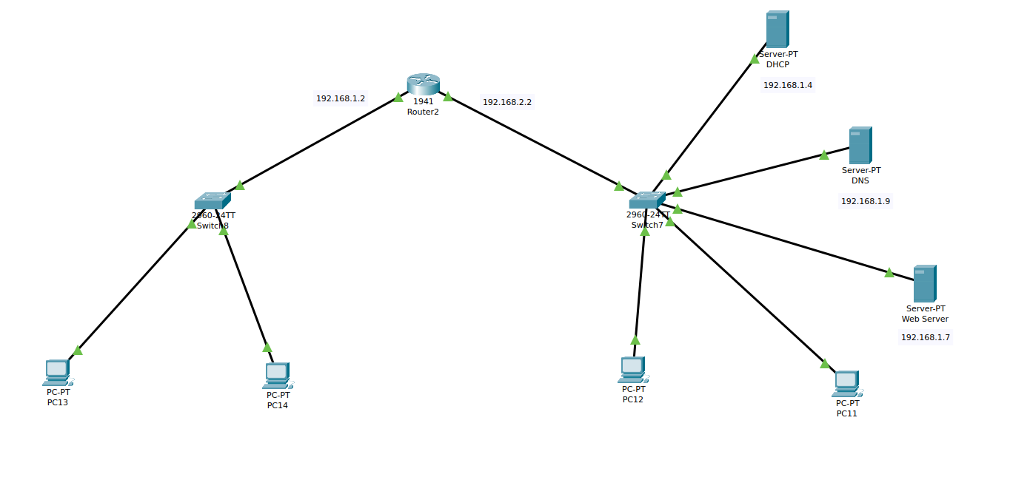
.

Router Setting For F0/0 And F0/1
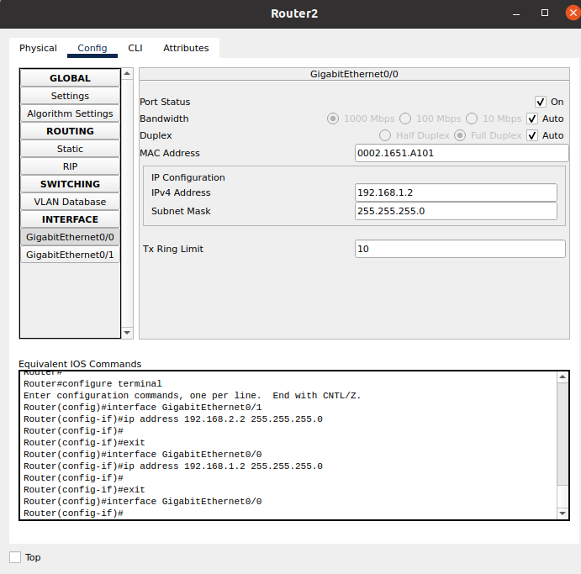
.

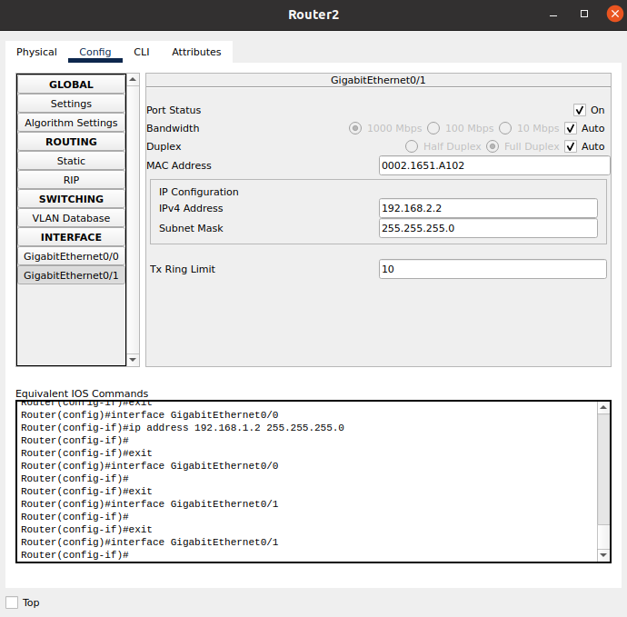
.

Applying Commands In The CLI Of The Router:
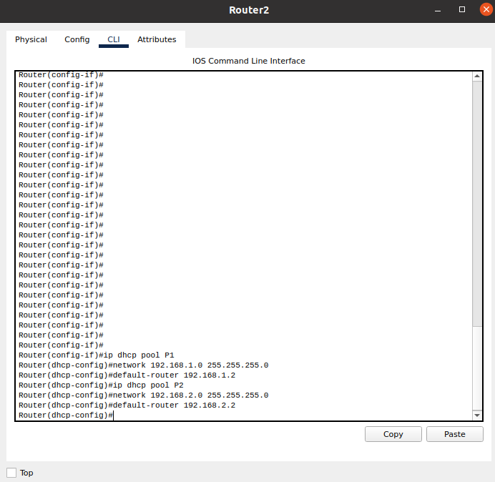
.

IP Configuration And DHCP Settings For DHCP Server:
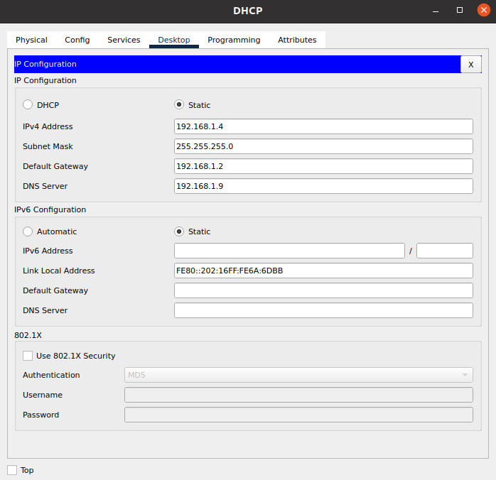
.

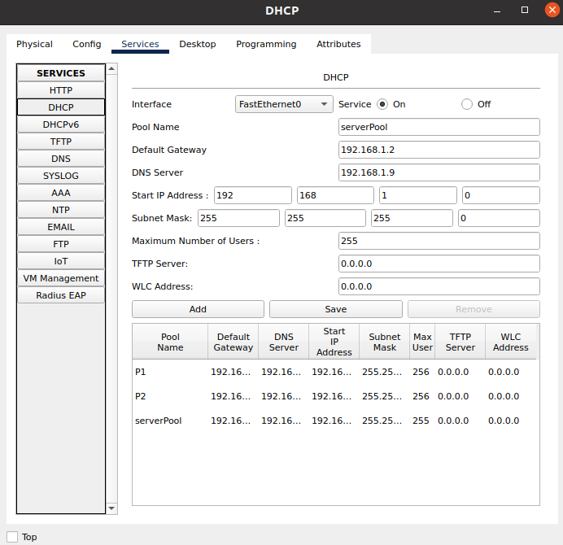
.

IP Configuration And DNS Settings For DNS-Server:
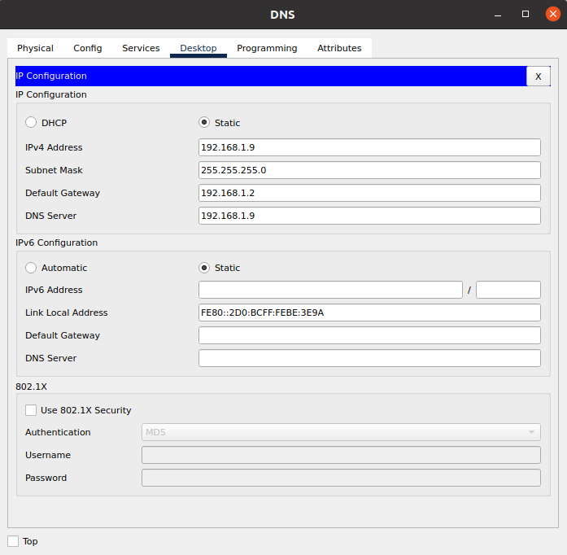
.

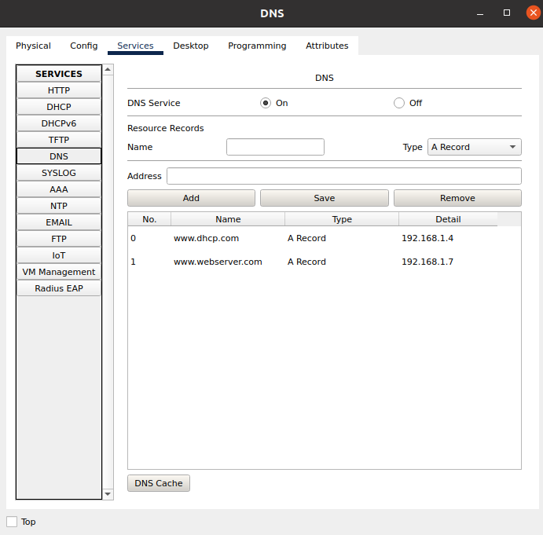
.

IP Configuration And HTTP Settings For Web-Server:
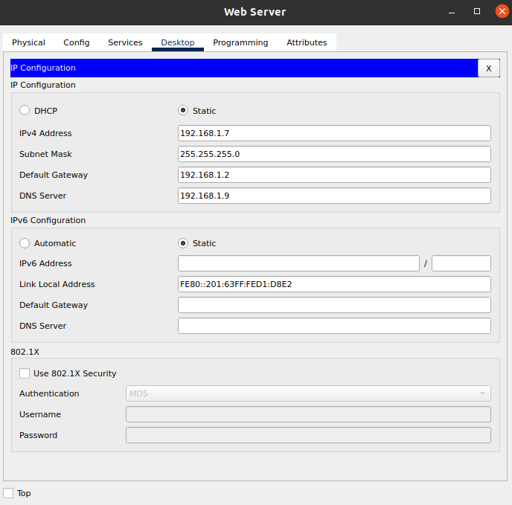
.

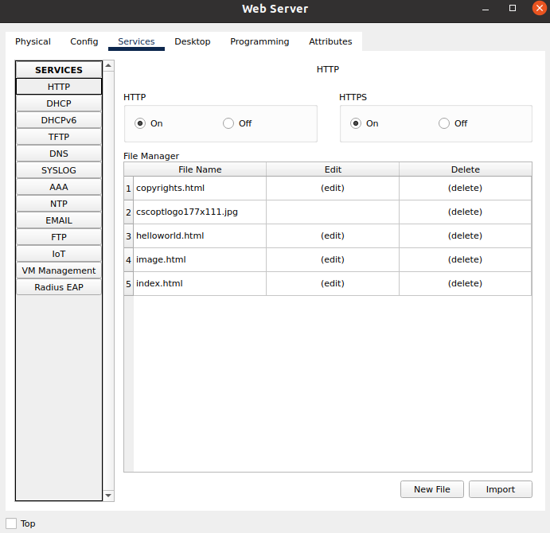
.

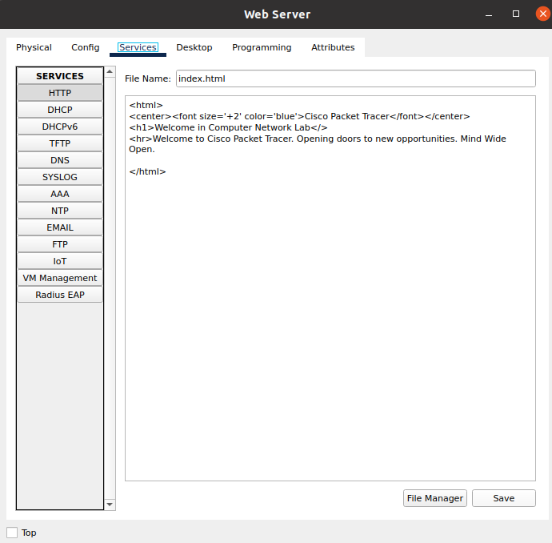
.

Enabling DHCP For All PC’s:
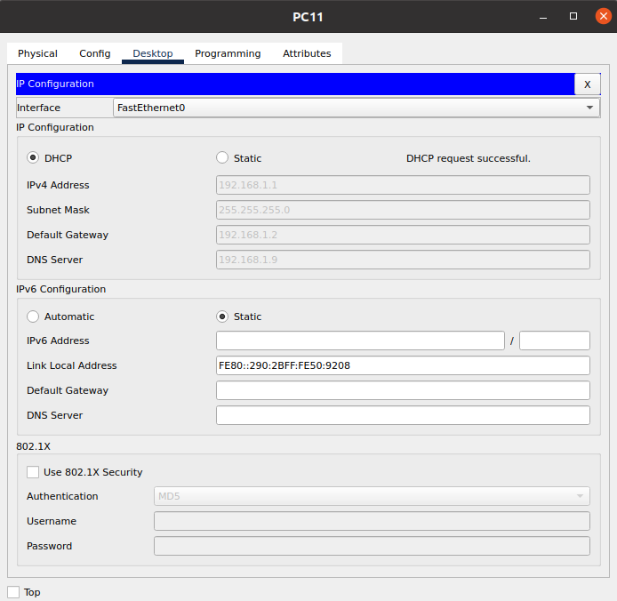
.

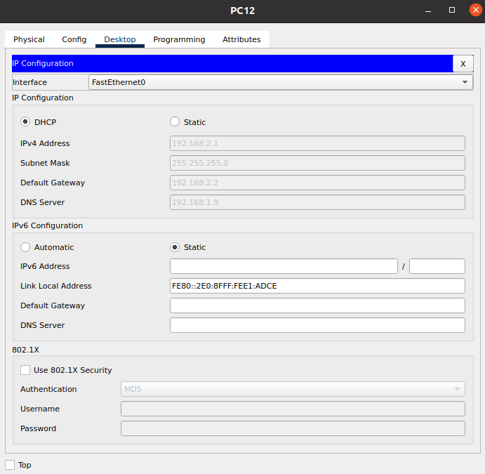
.

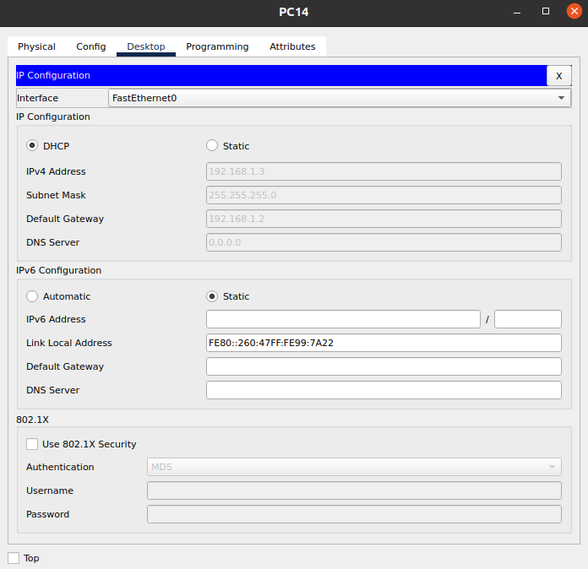
.

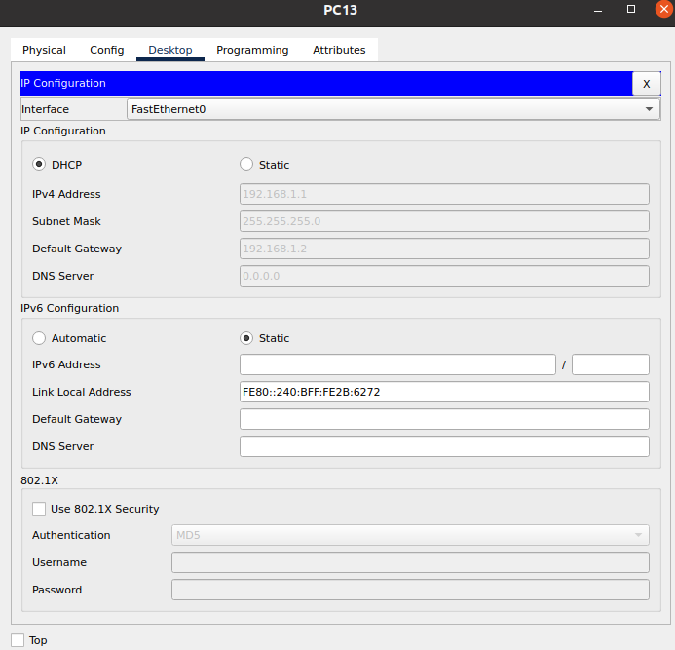
.

Pinging PC-12 From PC-14:
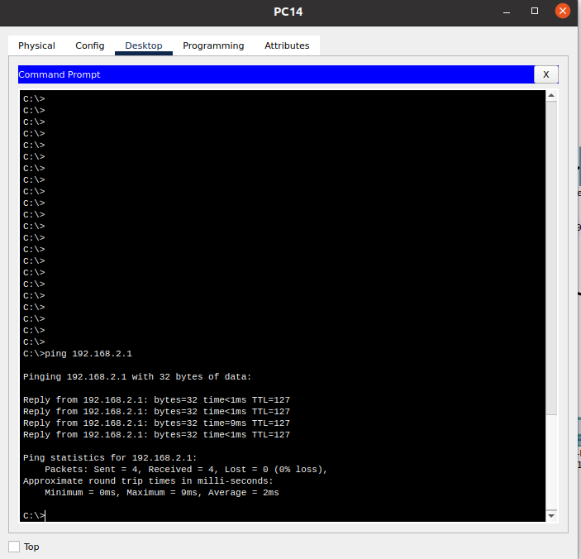
.

FIN.

